CIS 490 – Prototype #1 Research 2/15/17

## Options for Widget Build

Northrop Grumman has a few commercial libraries we can consider.

Two viable options to choose from so far.

**Sencha**

* Offers a huge collection of high-performance, customizable UI widgets
* These JavaScript widgets leverage HTML5 features on modern browsers while maintaining compatibility and functionality for legacy browsers
  + will fulfill the requirements that Ty set out for us
  + Components -> Data Binding -> Dynamic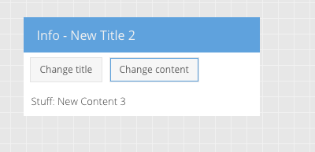

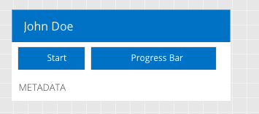

* + UI dynamically changes based off of inputs, could be a key component to demonstrate state changes in our workflow (other types of data binding options to configure)
  + Components also offer dynamic form fields, should be able to configure the forms to the dynamic UI for state changes and other modifications of the workflow

**Vaadin**

* Offers support for IE11, Edge as well as Firefox
* Offers for customization and a cleaner interface
* These elements work on any HTML5 based stack
* Elements -> Paper-Card

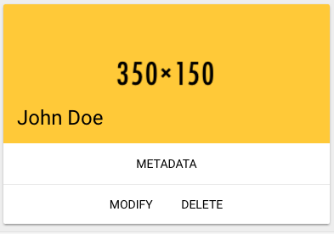

* Instead of progress bar, we could color coat the header (i.e. green for good progress, yellow if falling behind, red if behind etc.)
* Can integrate more options into these buttons like context menus (dropdown)

**GoJS** - $2995 / developer

<http://gojs.net/latest/samples/pageFlow.html>

* + Accepts JSON input
  + Features interactive features (can delete on command and drag arrows to connect existing modules
  + Drag and drop is highly desirable in our workflow
  + If we can find a freeware version of this, might be the best choice
  + Supports IE9+ and Firefox (will have to look at what version of Firefox), and if Edge is supported

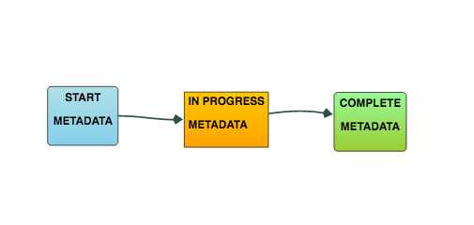

* Highly customizable